University of Cambridge Holiday Playscheme
Planned Activities: Easter 2020
Over the holiday, there will be a wide variety of planned activities available, shown in the timetable below. If children do not wish to participate in these then there are many other play opportunities available. Some children prefer to play and organise their own games with friends, and there are always other activities on offer such as arts and crafts, sports, rollerblading, board games, construction, den building, woodwork, music, role play, fancy dress, cooking, reading, messy play, water play, group games and much, much more! Please note that occasionally activities may change with no warning. Activities can also get rather messy so please bring appropriate clothing.

Trips

Trips are usually optional and some children will remain at the settings where activities will run as normal. We ask for a £2 donation per child for any trips your children attend. Please note that we use public transport for trips. All trips and activities may change due to circumstances beyond our control. Departure times for trips will vary, however we suggest you arrive early on the morning of a trip to register interest with the Site Co-ordinator. Please note they will book up on a first come first serve basis.

Friday Film Club

Each Friday we will be showing a film. These films all have a ‘U’ or ‘PG’ rating so please feel free to ask the Site Co-ordinator which film will be on offer. The over 11s will have the option to watch a different film on these days more suited to their age. Some of these are rated ‘PG’ and others ‘12’. The film watching is optional, and children may continue with the usual play opportunities if they wish.

Your child will need to bring to Playscheme:

- Clothing suitable for messy and water play, and spare clothing to change into when necessary (all items named please)
- Coats for cold or wet days (named please)
- Packed lunch (with cool pack & named)
- Swimming costume & towel for swimming trips (8yrs +)
- Backpack/bag that your child can use for trips
- Water bottles (named)
- Sunscreen and sun hat

Mobile Phones and Electronic Devices:

For safeguarding purposes, it is UCHP’s preference that your child does not bring a mobile phone or other electronic device with them to Playscheme. If you want to provide them with a mobile phone then UCHP takes no responsibility if it is damaged. Children must keep their mobile phone is their bag and will only be able to access it for appropriate reasons with permission from the Site Co-ordinator. Children aged 11 and over may sign in an electronic device and keep this in their bag; however, the data roaming on the phone must be turned off. The phones are only to be used in the over 11’s room or if special permission has been given.

Contact numbers during Playscheme:

Red Team (Chesterton) Site: 07739 985504 Playscheme Co-ordinator: 07985 735725
Blue Team (St Mary’s) Site: 07739 985506 Playscheme Deputy Co-ordinator: 07377 944519

If your call is urgent and you cannot get through to the venues, please contact the Playscheme Co-ordinator during Playscheme hours.

Week 1
Monday  30th March | 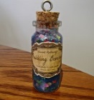 | Build a Hammock  Safari Chase  Make a Kazoo  Potions | Today we can build a hammock that hangs from the trees and pretend to be animals whilst escaping from the park ranger. We can make our own kazoo and create magical potions out of anything you can find at Playscheme.
Tuesday  31st March | 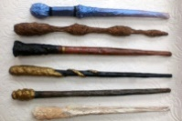  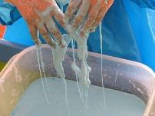 | Bottle Rockets  Squash  Make Your Own Wand  Cornflour Gloop | Today we can make a bottle rocket, which will explode, into the sky and we can play a fast-paced game of squash. We can make our own magical wand and get messy with cornflour gloop.
Wednesday  1st April |  | Harry Potter Duel  Skating Slalom  Easter Cards  Baguette Pizzas | Today we can use our magical wands to take part in a Harry Potter duel and we can race on roller skates. We can create colourful Easter cards for our friends and make a pizza using our favourite toppings.
Thursday  2nd April | Workshop: Yoga
 | 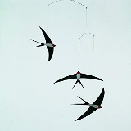  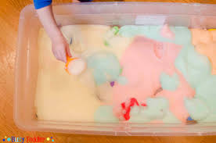 | Zen Gardens  Animal Races  Bird Mobiles  Bubble Foam | Today we can make an interesting zen garden, pretend we are animals and have a speedy race, make colourful bird mobiles and get messy with bubble foam.  Yoga: 4 – 8 year olds from 11:00 – 11:45 and 9 – 15 year olds from 11:45 – 12:30.
Friday  3rd April | Trip: Lammas Land
 | 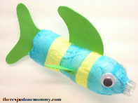 | Balloon Modelling  Croquet  Under the Sea  Chess Competition | Today we can make shapes out of balloons, play a calming game of croquet, create sea creatures out of recycled water bottles, and we can compete against each other to find the Playscheme chess champion.  Park trip: time to be confirmed, please sign up on site on a first come first served basis.

Week 2
Monday  6th April | Workshop: Pokémon Trainer
 |  | Parachute Games  Crab Football  Easter Bunny Ears  Fire Pit S’Mores | Today we can run under a parachute, play a game of football that has an unusual twist, create some colourful bunny ears, and make a tasty s’more around a fire.  Pokémon workshop: St Mary’s at 11:00 – 12:30.
Tuesday  7th April | Trip: Over 8’s Swimming
 | 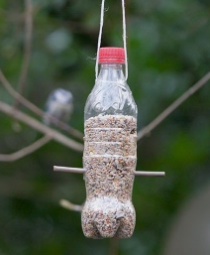 | Guess The Jellybean  Skipping Games  Bird Feeder  Egg Survival | Today we can see who can guess the most jellybean flavours and see how many we can get skipping at one time. We can see who can build a house to protect an egg from being dropped from a flight of stairs and we can make a bird feeder.  Over 8’s swimming trip: time to be confirmed, please sign up on site on a first come first served basis.
Wednesday  8th April | Trip: Under 8’s Botanical Gardens
 | 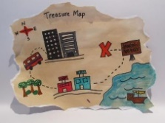 | Graffiti Banner  Ultimo 4-Square  Treasure Maps  Modroc Easter Eggs | Today we can create our own graffiti tag using spray paint and we can play a huge game of 4-square. We can create a real treasure map to help us find the hidden treasure and we can make Easter eggs out of Modroc.  Botanical Gardens trip: 11:00 – 14:00, please sign up on site on a first come first served basis.
Thursday 9th April |  | Easter Egg Hunt  Playscheme Decathlon  Tissue Paper Flowers  Easter Egg Nests | Today we can go on a hunt around Playscheme to find Easter eggs and we can compete against each other to complete the 10-event challenge. We can create a big pom-pom flower out of tissue paper and make some tasty chocolate egg nests.
Friday  10th April | NO PLAYSCHEME

Week 3
Monday  13th April | NO PLAYSCHEME
Tuesday  14th April |  | Sand Sculptures  Bat Tag  Pin The Tail  Jam Tarts | Today we can build some interesting sand sculptures and we can play a game of stuck in the mud, which has a superhero twist. We can play pin the tail on the bunny and bake some delicious jam tarts to take home.
Wednesday  15th April | Trip: Local Park
 | 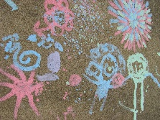 | The Great Chase  Badminton  Crushed Chalk Painting  Knowledge Quiz | Today we can test our speed in different games of chase and make beautiful paintings using crushed chalk. We can perfect our badminton skills and put our brains to the test by doing a knowledge quiz.  Park trip: time to be confirmed, please sign up on site on a first come first served basis.
Thursday  16th April | Trip: Over 11’s Cinema
 | 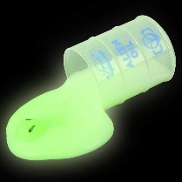 | Sardines  Egg and Spoon Race  Batik  Alien Slime | Today we can play sardines by seeing how many children we can fit into a small space and race each other holding a spoon and an egg. We can create interesting designs using hot wax and get messy with slime.  Cinema trip - time to be confirmed, please sign up on site on a first come first served basis.
Friday  17th April | Workshop : Pokémon Trainer
 |  | The Apprentice  Table Tennis Tournament  Bows and Arrows  Face Painting | Today we can work as a team to win the apprentice, practice our table tennis skills in a tournament, make a bow and arrow out of bamboo, and get our face painted.  Pokémon workshop: Chesterton at 11:00 – 12:30.

