University of Cambridge Holiday Playscheme
Planned Activities: Summer 2018
Over the holiday there will be a wide variety of planned activities available, shown in the timetable below. If children do not wish to participate in these then there are many other play opportunities available. Some children prefer to play and organise their own games with friends, and there are always other activities on offer such as arts and crafts, sports, rollerblading, board games, construction, den building, woodwork, music, role play, fancy dress, cooking, reading, messy play, water play, group games and much, much more! Please note that occasionally activities may change with no prior warning. Activities can also get rather messy so please bring appropriate clothing.

Trips
There will be trips scheduled most weeks during the summer. Some of these trips are specifically for children aged under eight, over eight or over 11. Please see the time table.
We ask for a £2 contribution per child for each trip they attend.
Themed Friday and Friday Film Club
Each Friday we will be showing a film that will relate to our theme of the day. These films all have a ‘U’ rating which means that they are suitable for all ages. The over 11s will have the option to watch a different film on these days more suited to their age. Some of these are rated ‘PG’ and others ‘12’. The film watching is optional, and children may continue with the usual play opportunities if they wish.

Your child will need to bring to Playscheme:
• Clothing suitable for messy and water play, and spare clothing to change into when necessary (all items named please)
• Coats for cold or wet days (named please)
• Packed lunch (with cool pack & named)
• Swimming costume & towel for swimming trips (8yrs +)
• Backpack/bag that your child can use for trips
• Water bottles (named)
• Sunscreen and sun hat

Mobile Phones and Electronic Devices:
For safeguarding purposes, it is UCHP preference that your child does not bring a mobile phone or other electronic device with them to Playscheme. If you want to provide them with a mobile phone then UCHP takes no responsibility if it gets damaged. Children must keep their mobile phone is their bag and will only be able to access it for appropriate reasons with permission from the Site Co-ordinator. Children aged 11 and over may sign in an electronic device and keep this in their bag; however, the data roaming on the phone must be turned off. The phones are only to be used in the over 11s room or if special permission has been given.

Contact numbers during Playscheme:
Red team (Chesterton) Site: 07498 045121
Blue Team (St Mary’s) Site: 07794 588405
Playscheme Co-ordinator: 07985 735725
Playscheme Deputy Co-ordinator: 07377 944519

If your call is urgent and you cannot get through to the venues, please contact the Playscheme Co-ordinator during Playscheme hours.

WEEK 1
Monday  9th July | 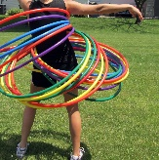  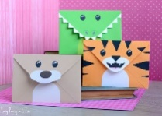 | Swamp Escape  Hoop Challenge  Envelope Animals  Shrinkles | Today we are going to cross a deadly swamp and create animals out of envelopes. We will see who can balance a hoop for the longest and make colourful shrinkles.
Tuesday  10th July | 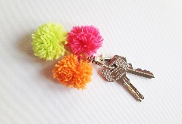  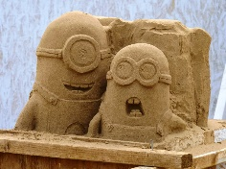 | Sand Sculptures  Benchball  Pom Pom Keyrings  Cardboard Warriors | Today we are going to get messy with sand, creating all sorts of sculptures. We will re-enact battles wearing costumes made from cardboard, we will get into a tangle with wool while making pom-poms, and we will enjoy a team game of benchball.
Wednesday 11th July | Trip: Lammas Land
 | 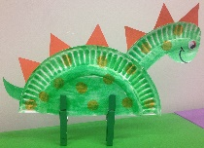 | Frozen Tag  Storytelling and acting  Dino Craft  Bowls | Today we can play the ‘Frozen’ inspired game of tag and create a performance by telling stories. We can create a dinosaur door hanger and relax outside whilst playing a game of bowls.  Park trip – time to be confirmed, please sign up on site, first come first served.
Thursday 12th July |  | Pokémon Bookmarks  Football Skills  Gingerbread creations  Sack Races | Today we can practise our football skills and enjoy baking some tasty gingerbread. We will see who can jump the fastest whilst standing in a sack and design some colourful Pokémon bookmarks.
Friday  13th July | Themed Friday: The Jungle
 | 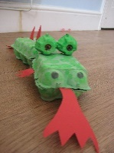  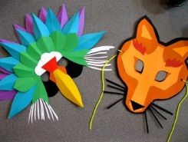 | Safari Chase  Animal Masks  Animal Quiz  Jungle Junk Modelling | Today we will imagine we are rangers and chase the escaped animals, test our knowledge on the animal kingdom in a quiz. We will decorate masks to look like our favourite animals and build a ginormous jungle habitat just from junk.

WEEK 2
Monday  16th July | Trip: Lammas Land
 | 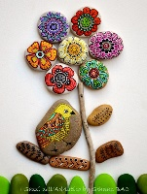 | Build a Hammock  Ultimate 4 Square  Hand Painted Stones  Batik Designs | Today we will construct hammocks strong enough to lie in, we will play ‘compete to be king of the court’ in a game of Ultimate 4 Square. We can decorate stones with intricate patterns to give as a gift, or keep for ourselves, and we can try the Indonesian art of Batik using wax and cloth to create beautiful designs.  Park trip – time to be confirmed, please sign up on site first come first served.
Tuesday 17th July | 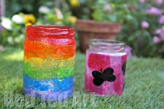 | Zumba  Long Distance Running  Search for Survival  Summer Lanterns | Today we will join in with an energetic class of Zumba and create a colourful lantern to put in a garden. We will test our stamina in a long distance running race and in teams we will create a raft to escape the sinking ship.
Wednesday  18th July | 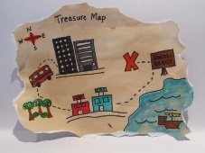 | Ultimate Noughts & Crosses  Basketball  Map Making  Magnets | Today we will practise our speed and agility in a game of basketball and chalk up a game of noughts and crosses on the playground. We will practise the art of cartography to ensure we don’t get lost, and we will feel the force when we play with magnets.
Thursday 19th July |  | Zen Gardens  Rollerblade Races  Pasta Photo Frames  Chocolate Chip Cookies | Today we will create a chilled space in our mini zen gardens, we will see who the speediest skater is in the rollerblade races, we repurpose pasta to decorate photo frames with and cook up some chocolatey treats in the kitchen.
Friday  20th July | Themed Friday: Mad Hatters Mayhem  Visitor: Yoga
 | 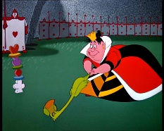 | Crazy Face Painting  Magic Door  Funky Tea Cups  Wonderland Croquet | Today our theme is based on the wild adventures of ‘Alice and Wonderland’. We will get our face painted and play a confusing game of wonderland croquet. We will create a magic door to get us into Wonderland and create funky tea cups out of paper plates.  Yoga workshop: 10:45 – 12:15, please sign up on site.

WEEK 3
Monday 23rd July | Trip: Botanical Gardens
 | 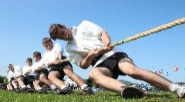 | Tug of War  Paper Aeroplanes  Elemental Process Art  Hydrophobic Sand | Today we will test our strength with a game of tug of war and create interesting art out of different elements. We can create paper aeroplanes and see how far they fly and create our own colourful sand.  Botanical Gardens trip – 11:00 – 14:00, please sign up on site on a first come first served basis.
Tuesday 24th July | 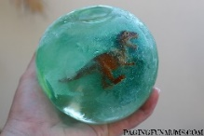 | Cops & Robbers  Playscheme Lacrosse  Junk Modelling Robots  Balloon Modelling | Today we will imagine we are cops and catch all of the robbers, we will create robots out of recycled junk. We can practice our throwing and catching skills with a game of lacrosse and we can learn how to shape balloons into animals.
Wednesday 25th July | Workshop: Football coaching
 | 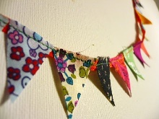  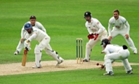 | Cricket  Bunting  Blindfolded Olympics  Frozen Dinosaur Eggs | Today we will be practising our teamwork in a game of cricket, we will be stitching together colourful bunting decorations. We can hop, skip and jump our way through some Olympic challenges whilst blindfolded and we can freeze dinosaur eggs and watch them melt.  Football workshop: St Mary’s at 10:45 – 12:30 & Chesterton at 13:30 – 15:15, please sign up on site.
Thursday  26th July | Workshop: Drama
 | 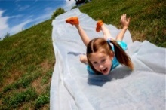 | Slip & Slide  Dot Art  4 Square Volleyball  Make Your Own Cereal Bar | Today we will create art inspired by the Aboriginals using patterns of intricate dots, and we will combine the classic Playscheme game of 4 square with the rules of volleyball to create a new challenging game. Will be getting wet on a water slide and re-boost our energy with a homemade cereal bar.  Drama workshop: Chesterton at 11:00 – 12:30 & St Mary’s at 13:30 – 15:00, please sign up on site.
Friday  27th July | Trip: Over 11’s Punting  Themed Friday: Clowning Around
 |  | Juggling  Funny Faces  Clown Maze  Pie Face | Today our theme is clowning around and we will all become clowns for the day. We will learn how to juggle, create funny faces out of paper plates, use our navigation skills to get through a funny maze and learn how to do the ultimate clown act of throwing pies.  Over 11’s punting trip – time to be confirmed, please sign up on site.

WEEK 4
Monday 30th July | 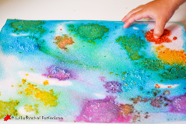 | Wrestling  Hula Hoop Relay  Painting With Salt  Cake Pops | Today we can get in the ring and challenge each other to a wrestling match and bake delicious cakes that look like lollipops. We will test our hula hoop skills by turning the game into a relay race and create a colourful painting out of salt.
Tuesday  31st July | Trip: Under 8’s Splash Pad
 | 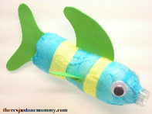 | Last Ninja  10 Pin Bowling  Rubbish Sandcastles  Under The Sea | Today we will play the fast paced game of last ninja and we will see who can create the worst sandcastle. We will aim for a strike in a bowling competition with friends and create a fish out of water bottle. Under 8’s splash pad trip – time to be confirmed, please sign up on site on a first come first served basis.
Wednesday  1st August | Visitor: Animal Experience
 |  | Bopper Wapper  Badminton  Hexa-flexagon  Vegetable Kebabs | Today we will be challenging each other in the playground game bopper-wapper, and creating paper hexaflexagons we can colour and play with. We will be getting our aprons on to whip up some veggie kebabs and enjoying a round of badminton with a friend.  Animal experience workshop – time to be confirmed, please sign up on site.
Thursday  2nd August | Trip: Over 8’s Swimming
 |  | Team Building  Tag Rugby  Star Wars Battle  Bird feeders | Today we will work as a team to recreate a tricky drawing, make a bird feeder out of a recycled water bottles and play the tactical game of tag rugby. We can create our own lightsaber and battle it out imaging we are in a star wars film.  Over 8’s swimming trip – time to be confirmed, please sign up on site ona first come first served basis.
Friday  3rd August | Themed Friday: History of Play
 | 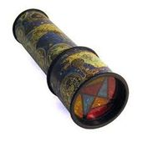  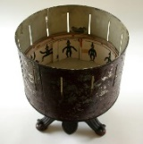 | Create a Kaleidoscope  Quoits  Hoop and Stick  Zoetrope | Today we are going to explore different types of play from the Victorian times. We will create our own kaleidoscope out of toilet rolls and glitter, we will play the tactical game of quoits. We will create our own film by making a zoetrope and play the simple but popular Victorian game of hoop and stick.

WEEK 5
Monday 6th August |  | Chalk Spray Paint  Tennis  Musical Instruments  Baguette Pizzas | Today we can design a graffiti tag with chalk and paint and we can compete in a tennis competition. We can invent a musical instrument and bake tasty pizzas using a baguette and vegetables.
Tuesday  7th August | Trip: Over 11’s Bowling
 | 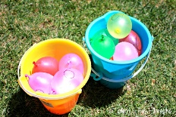 | Water Games  Skipping Games  Straw Paint Fireworks  Beetle Drive | Today we hope that the sun will be out so we can get wet whilst playing water games. We will see how long we can skip for, create colourful fireworks and see who can draw a beetle first.  Over 11’s bowling trip – time to be confirmed, please sign up on site.
Wednesday  8th August | Trip: Museum
 | 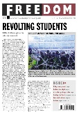 | Sardines  Netball  Oil Pastel Creations  Create a Newspaper | Today we will play sardines which is an adaption of the classic game hide and seek, we can practice our shooting skills with a game of netball. We can create an oil pastel drawing and write articles for the Playscheme newspaper.  Museum trip – time and booking to be confirmed, please sign up on site on a first come first served basis.
Thursday  9th August | Workshop: Superheroes
 | 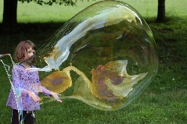 | Giant Bubbles  Hurdle Training  Envelope Baskets  Group Games | Today we can see who can create the biggest bubble and see who can jump the highest. We can create a basket to keep our treasures safe and we can join in with some fun group games such as cat and mouse.  Superhero workshop: St Marys at 9:15 – 12:15 & Chesterton at 13:15 – 16:15.
Friday  10th August | Themed Friday: Magical Mayhem
 | 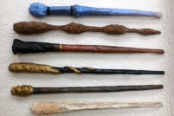 | Magic Show  Trading Cards  Magic Wands  Sorcerer’s Stone | Today we are going to become magicians for our magical mayhem themed day. We can create our own set of playing cards to use with our friends and create a real magical wand to cast spells with. We can compete in a quest to find the sorcerer’s stone and we can learn tricks to perform at the Playscheme magic show.

WEEK 6
Monday  13th August | 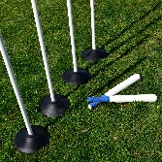  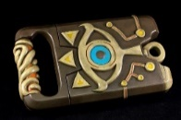 | Chalking  Rounders  Sheikah Slate  Fluffy Slime | Today we can cover the playground in beautiful chalk designs and work as a team to play a game of rounders. We can create our own sheikah slate from the popular ‘Zelda’ game and we can make slime that feels and looks fluffy.
Tuesday 14th August | Trip: Under 8’s Soft Play
 | 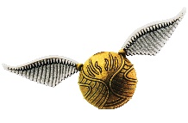 | Master Chef  Hula Hoop Freeze Tag  Dodgeball  Golden Snitch | Today we can imagine we are taking part in the TV show ‘Master chef’ and bake a delicious treat. We can catch each other with hula hoops whilst playing tag and test our reaction time with a game of dodgeball. We can create a golden snitch which features in the ‘Harry Potter’ films.  Under 8’s soft play – St Mary’s 13:00 – 16:00 and Chesterton 14:45 – 16:15, please sign up on site on a first come first derved basis.
Wednesday 15th August | Trip: Over 8’s Swimming
 | 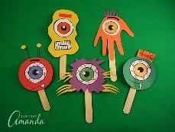 | Miniature Forests  Crazy Golf  Stick Monsters  Playscheme’s Got Talent | Today we can play on a crazy golf course we have designed ourselves and make some marvellously terrifying stick monsters with collage and card. We will be foraging for twigs and branches to use in our miniature forests and we will be performing in front of our friends in the Playscheme talent show.  Over 8’s swimming trip – time to be confirmed, please sign up on site on a first come first served basis.
Thursday  16th August | Visitor: Yoga
 | 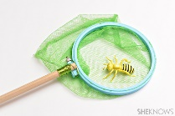  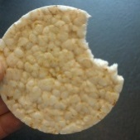 | Bug Hunt  Table Tennis Comp  Finger Puppets  Rice Cake Challenge | Today we will be testing out our table tennis skills and crown a Playscheme champion, we will be inspecting the habitats of mini-beasts and sewing together some fun finger puppets to play with and see who is the speediest rice cake eater.  Yoga workshop: Chesterton at 10:45 – 12:15 & St Marys at 13:30 – 15:00
Friday  17th August | Themed Friday: Street Party
 | 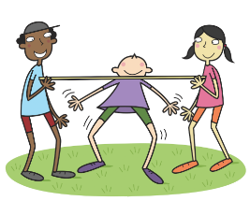 | Face Painting  Tin Can Shoot Out  Limbo  Friendship Bracelets  Movie Quiz | As it is the last day at our St Mary’s site we thought we would have a street party to celebrate at both sites. In the morning we will create the activities for the street stalls and we will turn the playground into a street party. In the afternoon we will enjoy the street party, there will be games such as limbo and tin can shoot out. We can get our face painted and create a bracelet for a friend. We will finish the day with a quiz based on different films.

WEEK 7
Monday 20th August | 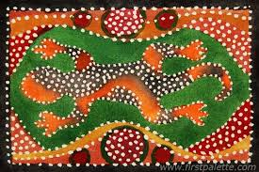 | Playground Squash  Croquet  Batik Designs  Dance Off | Today we can play the fast paced game of squash and use a traditional Indonesian method of hand printing textiles by melting wax and dye. We can see who can hit a wooden ball through a plastic hoop in a game of croquet and we can throw some shapes in a dance off competition.
Tuesday  21st August | 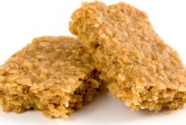  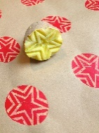 | Tennis  Bulldog  Flapjack  Potato Printing | Today we can go to the Sports Centre’s tennis courts to play a game or two and we can create delicious flapjacks to take home. We can play the speedy game of bulldog and create pictures with potatoes and paint.
Wednesday 22nd August | Trip: Treasure Hunt Trail
 | 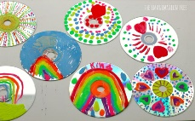 | Football Skills  Quidditch  Laboratory Experiments  CD Art | Today we can show off our football skills and fly on a broom stick to play a game of ‘Harry Potter’ Quidditch. We can become scientists and create an experiment and we can draw on old CD’s to make art.  Treasure hunt trail – time to be confirmed, please sign up on site on a first come first served basis.
Thursday  23rd August | Trip: Jesus Green Park
 | 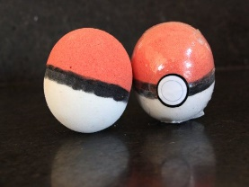 | Crime Scene Investigation  Rollerhockey  Elastic Band Stamps  Fizzing Pokeball | Today we can become an FBI agent and investigate a crime scene, we can put our skates on and play a game of rollerhockey. We can create a stamp out of elastic bands and make the famous Pokémon pokeball by creating a chemical reaction.  Park trip – time to be confirmed, please sign up on site on a first come first served basis.
Friday  24th August  (Half Day close at 1pm) |  | Playscheme Sports Day! | Today is the last day of the Summer Playscheme so we have decided to do something special. We are going to the Castle field opposite Chesterton school to have a Playscheme sports day. There will be lots and lots of fun activities to get involved in, for example, egg and spoon race, sack race, face painting and a water race. We will be at the field from 10:00 – 12:00.

