University of Cambridge Holiday Playscheme
Planned Activities: Summer 2021

Over the holiday there will be a wide variety of planned activities available, shown in the timetable below. If children do not wish to participate in these then there are many other play opportunities available. Some children prefer to play and organise their own games with friends, and there are always other activities on offer such as arts and crafts, sports, rollerblading, board games, construction, den building, woodwork, music, role play, cooking, reading, messy play, water play, group games and much, much more! Please note that occasionally activities may change with no prior warning. Activities can also get rather messy so please bring appropriate clothing.

Friday Film Club

Each Friday we will be showing a film. These films all have a ‘U’ or ‘PG’ rating so please feel free to ask the Site Co-ordinator which film will be on offer. The over 11s will have the option to watch a different film on these days more suited to their age. Some of these are rated ‘PG’ and others ‘12’. The film watching is optional, and children may continue with the usual play opportunities if they wish.

Your child will need to bring to Playscheme:
• Clothing suitable for messy and water play, and spare clothing to change into when necessary (all items named please)
• Coats for cold or wet days (named please)
• Packed lunch (with cool pack & named)
• Water bottles (named)
• Sunscreen and sun hat

Mobile Phones and Electronic Devices:

For safeguarding purposes, it is UCHP preference that your child does not bring a mobile phone or other electronic device with them to Playscheme. If you want to provide them with a mobile phone then UCHP take no responsibility if it gets damaged. Children must keep their mobile phone in their bag and will only be able to access it for appropriate reasons with permission from the Site Co-ordinator. Children aged 11 and over may sign in an electronic device and keep this in their bag, however, the data roaming on the phone must be turned off. The phones are only to be used in the over 11s room or if special permission has been given..

Contact numbers during Playscheme:

Red Team (Chesterton) Site: 07739 985504 Playscheme Co-ordinator: 07985 735725
Blue Team (St Mary’s) Site: 07739 985506 Playscheme Deputy Co-ordinator: 07377 944519

If your call is urgent and you cannot get through to the venues, please contact the Playscheme Co-ordinator during Playscheme hours.

WEEK 1
Monday  12th July | 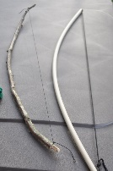 | Chalking  Sharks & fish  Bows & arrows  Paper aeroplane targets | Today we can create interesting pictures on the ground with chalk and we can play the fast paced game of sharks and fish. We can make our own bow and arrow and create paper aeroplanes to shoot at targets.
Tuesday  13th July | 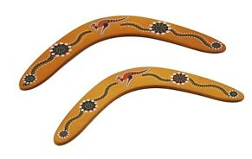 | Things that float  Rip tag games  Boomerang designs  Baguette pizza | Today we can make boats to float on the water and we can compete in rip tag games. We can make an Australian hunting weapon called a boomerang and bake some tasty pizzas to eat at Playscheme.
Wednesday 14th July | 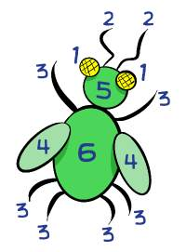  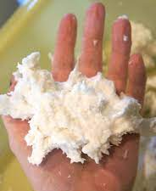 | Sorcerer’s stone  Oonch neech  Beetle drive  Clean mud | Today we can go on an adventure to complete quests to find the sorcerers stone and we can play a tag game which is played in Pakistan. We can compete to see who can draw a beetle in the quickest time and we can get messy with clean mud.
Thursday 15th July |  | Ultimate noughts & crosses  Benchball  Tissue paper flowers  What’s in the box? | Today we can create a giant game of noughts and crosses and play the fast paced game of benchball. We can make colourful flowers out of tissue paper and wear a blind fold and guess what is inside the box.
Friday  16th July | Themed Friday: Wild West
 | 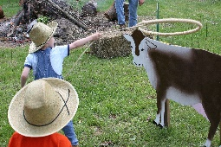 | Lasso toss  Cowboys & Indians  Hat making & parade  Wanted poster | Today we can see who can get a lasso around a target and we can defend our land against the cowboys. We can make a hat to show off in a Playscheme parade and we can make a wanted poster.

WEEK 2
Monday  19th July | 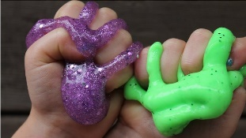 | Flower press  Hurdle training  Fridge magnets  Circle games | Today we can collect flowers and press them to take home and we can learn how to jump over a hurdle. We can make our own fridge magnets to take home and we can play some group games.
Tuesday 20th July | 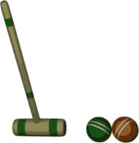 | Large ice marbles  Croquet  Night Lights  Bingo | Today we can make ice marbles by freezing water in a balloon and we can play a game of croquet. We can make colourful night lights from recycled jars and we can play a game or two of bingo.
Wednesday  21st July |  | Shuffle bottoms  Long jump  Custom playing cards  Slime | Today we can play the fun but unusual game of shuffle bottoms and we can see who can jump the furthest in a long jump competition. We can make our own playing cards and we can get messy with some slime.
Thursday 22nd July | 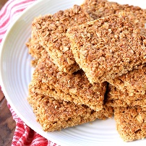 | 10 pin bowling  Safari chase  Make a kazoo  Flapjack | Today we can see who can knock all of the pins down and we can imagine we are animals running away from the park keepers. We can make a musical kazoo and bake some tasty flapjack.
Friday  23rd July | Themed Friday: Space
 | 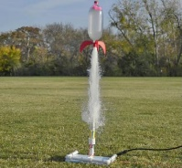 | Space scavenger hunt  Musical planets  Space mobile  Bottle rockets | Today we can see if we have it takes to become an astronaut and we can play the musical chairs with a twist. We can make colourful mobiles using planets and we can make a bottle explode like a rocket.

WEEK 3
Monday  26th July | Visitor: Cambridge Spanish Centre
 | 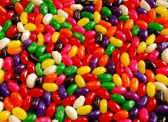 | Burn the city down  Rock, paper, scissors, catch  Piggy banks  Guess the jelly bean | Today we can build a model city out of cardboard and then at the end of the day we can watch it burn down. We can play a twist on the classic game of rock, paper, scissors and we can make a piggy bank out of recycled water bottles. We can put our taste buds to the test by guessing the flavour of a jelly bean
Tuesday  27th July | 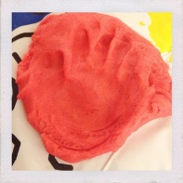 | Water games  Archery  Summer banner  Dinosaur fossils | Today we can get wet when playing some water games and we can have a go at shooting some arrows onto a target. We can make a colourful banner to put up at Playscheme and we can make a dinosaur fossil out of clay.
Wednesday  28th July | 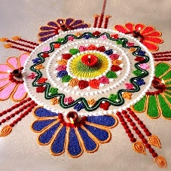  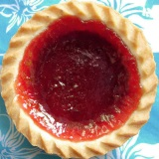 | Limbo  Hockey obstacle course  Rangoli designs  Jam tarts | Today we can see who can bend down the lowest in a game of limbo and we can navigate a ball around an obstacle course using a hockey stick. We can make colourful patterns which is a tradition in India and we can bake some tasty jam tarts.  Ukulele workshop will be done on both sites, times to be confirmed.
Thursday  29th July | 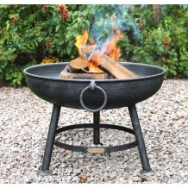 | Shadows  Shuttlecock games  Frog bean bags  Fire pit s’mores | Today we can play an Irish version of the game tag and we can play different games using shuttlecocks. We can learn how to sew and make a frog bean bag and we can toast some marshmallows on the fire to make a delicious s’more.
Friday  30th July | Themed Friday: Superheroes
 | 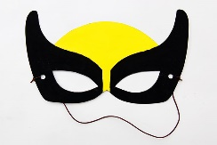 | Bean bag attack  Tug of War  Superhero masks  Superhero Hama beads | Today we can attack the naughty villains by throwing bean bags at tin cans and we can test our superhero strength with a game of tug of war. We can make a superhero or villain mask and we can make a superhero out of hama beads.

WEEK 4
Monday  2nd August | 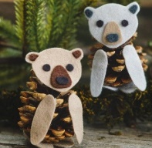  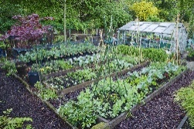 | Growing vegetables  Hide & seek it  Pinecone animals  Chess competition | Today we can plant our own vegetables and play the Playscheme game of hide and seek it. We can make animals out of pinecones and learn how to play chess.
Tuesday  3rd August | 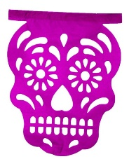 | Ice crayons  Hula hoop relay  Papel picado calavera  Master chef |  | Today we can create crayons out of ice and chalk and we work as a team to compete in a relay race. We can make decorations for the Mexican holiday ‘The day of dead’ and we can make a delicious dish in our very own Master chef competition.
Wednesday  4th August | 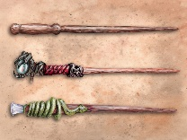  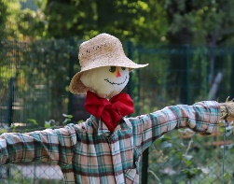 | Make a scarecrow  Rounders  Magic wands  Laboratory experiments | Today we can make a scarecrow to put in the garden at Playscheme and we can work as team in a game of rounders. We can make a magical wand and we can imagine we are scientists and create lab experiments.
Thursday  5th August | Visitor: Animal Experience
 | 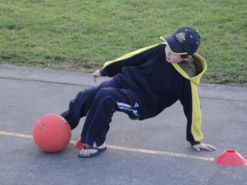 | Harry Potter duel  Crab football  Jewellery making  Woodwork | Today we can use our wands we made yesterday to have a wizard duel and we can get on our hands to play crab football. We can make colourful jewellery and construct something out of wood.  Animal experience - 10:45 to 12:15. Sign up at the start of the Playscheme day.
Friday  6th August | Themed Friday: Olympics
 | 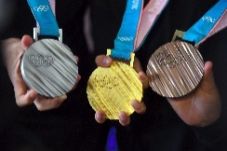 | Mini Olympics  Flag making  Olympic medals  Laser Tag | Today we can take part in the mini Olympic games and create a new Olympic game of laser tag. We can make a flag for the country we are representing and we can make Olympic medals out of clay.

WEEK 5
Monday  9th August | 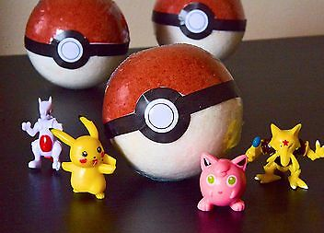 | Tin can shoot out  Handball  African collar necklace  Fizzing pokeball | Today we can test our aiming skills in the outdoor game of Tin can shoot out and we can play the tactical game of handball. We can make a traditional African collar necklace and we can watch the Pokeballs fizz away.
Tuesday  10th August |  | Visitor: Yoga workshop
 |  | Pilolo  Crazy golf  Bird feeder  Frozen dinosaur eggs | Today we can participate in a scavenger hunt that originated from Ghana and create a crazy golf course. We can make bird feeders from recycled bottles and freeze mini dinosaurs which we can then smash into pieces outside.  Yoga - St Mary’s @ 13:15 - 15:30
Wednesday  11th August | 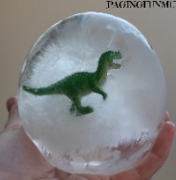  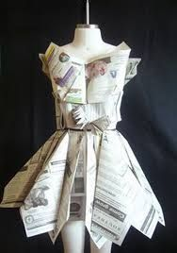 | Bug hunt  Animal races  Newspaper fashion show  Rainbow cupcakes | Today we can hunt for bugs and move like animals in a race. We can make an outfit out of newspaper for a fashion show and bake some tasty colourful cupcakes.
Thursday  12th August | 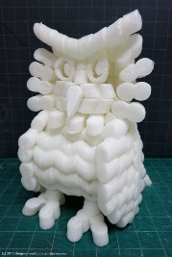 | Snowball fight  Man hunt  Packing peanut sculptures  Instant ice-cream | Today we can have a snowball fight and see who can catch the most people in a game of Man hunt. We can make our own packing peanut creation and make some tasty ice-cream.
Friday  13th August | Themed Friday: Acceptance
 | 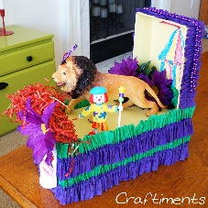 | Cheerleading  Cups & Saucers  Carnival Floats  Foam paint | Today we can choreograph a cheerleading routine to perform to our peers and we can see who is the quickest at turning over the cones to make saucers. We can make mini carnival floats to parade around Playscheme and create a colourful painting out of foam paint.

WEEK 6
Monday  16th August |  | Raft game  Basketball  The apprentice  Fluffy dough |  | Today we can create a raft to get our team across the river and we can play a game of basketball. We can invent a product to sell to the Apprentice judges and make some fluffy dough.
Tuesday  17th August | 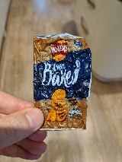  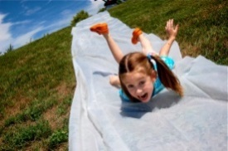 | Water fight  Sack race  Shrinking crisp packet  Egg survival | Today we can get wet on a water slide and race against each other in sacks. We can make shrinkles out of recycled crisps packets and create a container that will keep an egg safe if you drop it from a high height.
Wednesday  18th August | Visitor: Circus workshop
 | 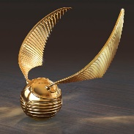 | Frozen t-shirt  Jianzi  Golden snitch  Dance battles | Today we can tie knots in a t-shirt which we then freeze and have to put on and play the traditional Chiense game Jianzi which uses a colourful shuttlecock. We can make a golden snitch from Harry Potter and show off our dancing moves in a Playscheme dance battle.
Thursday  19th August |  | Giant bubbles  Football  Catapults  Scones | Today we can test our memory in a game of What’s missing and play a game of football. We can shoot elastic bands from catapults and make some delicious scones.
Friday  20th August | Themed Friday: Pirates
 | 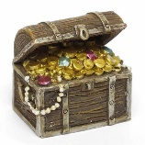  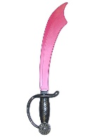 | Pirate treasure hunt  Capture the treasure  Make your own sword | Today we can pretend we are pirates going on an adventure to find the buried treasure and we can play capture the treasure which is a twist on capture the flag. We can make our own sword and battle it out in a sword fight.

